Musha Health Centre

Site Assessment

General Health Facility Information

Address:
Manager details: Tel: 0783254688
Email: maprosper2006@yahoo.fr
Primary contact person: MAHINGA Prosper
Type of health facility: Health Centre
Catchment population: 16,951
Primary referral site: RWAMAGANA DISTRICT HOSPITAL
Distance from main road: 2 KM
Total staff: 123
Total clinical staff: 13
Total number of IT staff: 3
Services are offered: Curative Preventive Care, Laboratory, Maternity, Pharmacy, Hospitalization, Vaccination, Family Planning, Antenatal Care, HIV (ARV/PMTCT/VCT), IMCI (Integrated Management of Childhood Illnesses)
Names of projects/programmes currently involved in: Global Fund

Antenatal Care

Location of ANC clinic: SEPARATE CLINC SITE
Number of ANC clinics per week: 2
Days of ANC clinics: FRIDAY (FIRST VISITS) WEDNESDAY (OTHER VISITS)
Total Maternity/ ANC clinical staff: 11
Number of new ANC visits per month: 60
Number of deliveries per month: 58
Number of case transfers/referrals per month: 17
Number of case transfers/referrals by ambulance per month: 17

ANC clinic workflow diagram:

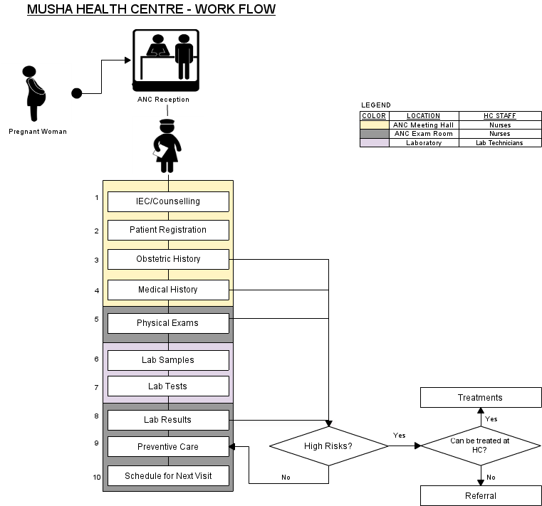

ANC clinic workflow description:

Women gather in multi-purpose hall that is used as waiting and registration area of the ANC. They received education/information and are registered, have their histories taken and weight taken. The women then move into waiting queue in corridor outside of exam room. The physical exam is done and blood pressure etc. done in exam room. Women are then sent across corridor to lab to have samples taken. Women then wait for results, which they are called into the exam room to get results, treatment/referral and schedule next appointment.

Encounter description:

FIRST VISIT | OTHER VISITS | DESCRIPTION
IEC/COUNSELLING |  | Information, Education Communication about Family Planning, HIV/AIDS, parenting, Breastfeeding...
PATIENT REGISTRATION |  | Filling the Demographics of the Pregnant Woman (names, address – Village/Cell Sector/District, Patient number, Partner's name, Date of birth,..)
OBSTETRIC HISTORY |  | Number of previous pregnancies, date & outcome of each event, special maternal complications & events in previous pregnancies, birth weights, obstetrical operations, special perinatal complications and events in previous pregnancies,...
MEDICAL HISTORY |  | Specific diseases & complications (Tuberculosis, heart diseases, chronic renal diseases, epilepsy, dibetes, high blood pressure, asthma, HIV/AIDS...)
PHYSICAL EXAMS | PHYSICAL EXAMS | Physical exams include (height & height, incremental weight gains, blood pressure, edema, breasts, severe anemia, temperature, uterine height, child heartbeat, ...)
LAB SAMPLES | LAB SAMPLES | - Blood  - Urine
LAB TESTS | LAB TESTS | - Blood: HIV/AIDS, Syphilis (RPR), Haemoglobin (Hb) in case of severe anemia  - Urine: Albumin,
LAB RESULTS | LAB RESULTS | These are the results of the lab tests.
PREVENTIVE CARE | PREVENTIVE CARE | These include: malaria prevention (Mosquito nets, sufadixine/pyrimetamine) Tetanus vaccinations, Iron & folate supplements, De-worming tablets (Mebendazole)
TREATMENTS | TREATMENTS | This happens in case of high risk complications that can be treated at the health centre
REFERRALS | REFERRALS | This happens in case of high risk complications that cannot be treated at the health centre
SCHEDULE NEXT VISIT | SCHEDULE NEXT VISIT

ANC Patient Registration and records
Person responsible for registering patients at clinic: ANC Nurse
Registration process:
Patient records accessed prior to consultation: ANC Nurse
Patient medical history tracked: Forms and Registers
Type of forms used to collect patient information: ANC Form, ANC Register, ANC Maternal Card, PMTCT Liaison Form
Person responsible for completing patient records: ANC Nurse
Patient records stored: ANC Communal Hall
People with access to patient records and reasons for access:
- ANC Nurse: Filling, Filing, Scheduling next visits, reference...
- Data Manager: Reporting and checking quality of data,..
- Titulaire: as the overall supervisor of the health centre, in case of referrals, quality assurance of data,...

Infrastructure
Power: GRID
Existing ITC systems at health facility: DHIS-2, OPENMRS
Number of existing computers at health facility 10
Number of UPS at health facility 4
Number of printers at health facility 3
Number of existing computers in ANC clinic 0
Number of UPS in ANC clinic 0
Number of printers in ANC clinic 0
Computer maintenance carried out by: IT Manager
LAN: YES
Internet: GPRS (MTN RWANDA)
Secure room/station in ANC for computer: ANC Meeting Hall (No), ANC Exam Room (Yes)

IT skills assessment

Beginner 50%
[the person no or close no computer skills]

Average 25%
[the person has used a computer now and then (can open files, switch on/off a computer, knows how to use a mouse, has an e-mail address & uses the internet)]

Advanced 25%
[definition]

