Murambi Health Centre Site Assessment

General Health Facility Information

Address:
Manager details: 0788782383 jingirente@yahoo.fr
Primary contact person: NGIRENTE Jean Marie Vianney
Type of health facility: Health Centre
Catchment population: 12,475
Primary referral site: RWAMAGANA DISTRICT HOSPITAL
Distance from main road: 2 KM
Total staff: 13
Total clinical staff: 7
Total number of IT staff: 1
Services are offered: Curative Primary Care, Laboratory, Maternity, Pharmacy, Nutrition, Hospitalization) Preventive Vaccination, Family Planning, Antenatal Care, HIV (PMTCT/VCT)/ARV)
Names of projects/programmes currently involved in: Global Fund

Antenatal Care

Location of ANC clinic: ON MAIN CLINC SITE
Number of ANC clinics per week: 2
Days of ANC clinics: FRIDAY (FIRST VISITS) WEDNESDAY (OTHER VISITS)
Total Maternity/ ANC clinical staff: 7
Number of new ANC visits per month: 60
Number of deliveries per month: 30
Number of case transfers/referrals per month: 10
Number of case transfers/referrals by ambulance per month: 10

ANC clinic workflow diagram:

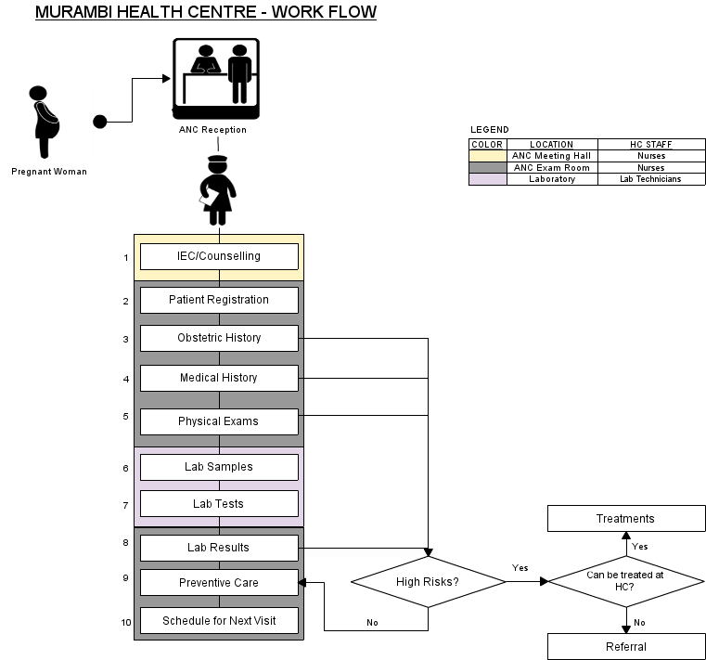
ANC clinic workflow description:

FIRST VISIT | OTHER VISITS | DESCRIPTION
IEC/COUNSELLING |  | Information, Education Communication about Family Planning, HIV/AIDS, parenting, Breastfeeding...
PATIENT REGISTRATION |  | Filling the Demographics of the Pregnant Woman (names, address – Village/Cell Sector/District, Patient number, Partner's name, Date of birth,..)
OBSTETRIC HISTORY |  | Number of previous pregnancies, date & outcome of each event, special maternal complications & events in previous pregnancies, birth weights, obstetrical operations, special perinatal complications and events in previous pregnancies,...
MEDICAL HISTORY |  | Specific diseases & complications (Tuberculosis, heart diseases, chronic renal diseases, epilepsy, dibetes, high blood pressure, asthma, HIV/AIDS...)
PHYSICAL EXAMS | PHYSICAL EXAMS | Physical exams include (height & height, incremental weight gains, blood pressure, edema, breasts, severe anemia, temperature, uterine height, child heartbeat, ...)
LAB SAMPLES | LAB SAMPLES | - Blood  - Urine
LAB TESTS | LAB TESTS | - Blood: HIV/AIDS, Syphilis (RPR), Haemoglobin (Hb) in case of severe anemia  - Urine: Albumin,
LAB RESULTS | LAB RESULTS | These are the results of the lab tests.
PREVENTIVE CARE | PREVENTIVE CARE | These include: malaria prevention (Mosquito nets, sufadixine/pyrimetamine) Tetanus vaccinations, Iron & folate supplements, De-worming tablets (Mebendazole)
TREATMENTS | TREATMENTS | This happens in case of high risk complications that can be treated at the health centre
REFERRALS | REFERRALS | This happens in case of high risk complications that cannot be treated at the health centre
SCHEDULE NEXT VISIT | SCHEDULE NEXT VISIT

ANC Patient Registration and records
Person responsible for registering patients at clinic: ANC Nurse
Registration process:
Patient records accessed prior to consultation: ANC Nurse
Patient medical history tracked: Forms and Registers
Type of forms used to collect patient information: ANC Form, ANC Register, ANC Maternal Card, PMTCT Liaison Form
Person responsible for completing patient records: ANC Nurse
Patient records stored: ANC Communal Hall
People with access to patient records and reasons for access:
- ANC Nurse: Filling, Filing, Scheduling next visits, reference...
- Data Manager: Reporting and checking quality of data,..
- Titulaire: as the overall supervisor of the health centre, in case of referrals, quality assurance of data,...

Infrastructure
Power: GRID
Existing ITC systems at health facility: DHIS-2
Number of existing computers at health facility 3
Number of UPS at health facility 2
Number of printers at health facility 1
Number of existing computers in ANC clinic 0
Number of UPS in ANC clinic 0
Number of printers in ANC clinic 0
Computer maintenance carried out by: Outsourced
LAN: No
Internet: GPRS (MTN RWANDA)
Secure room/station in ANC for computer: ANC Meeting Hall (Yes), ANC Exam Room (Yes)

IT skills assessment

Beginner 50%

Average 25%

Advanced 25%

