Gahengeri Site Assessment

General Health Facility Information
Address:
Manager details: Tel: 0788541273
Email: bihibindijean@yahoo.fr
Primary contact person: BIHIBINDI jean Christophe
Type of health facility: Health Centre
Catchment population: 22,302
Primary referral site: RWAMAGANA DISTRICT HOSPITAL
Distance from main road: 5.5 KM
Total staff: 18
Total clinical staff: 8
Total number of IT staff: 3
Services are offered: Curative (Laboratory, Maternity, Pharmacy, Minor Surgery, Tuberculosis, Hospitalization) Preventive (vaccination, Family Planning, Antenatal Care, PMTCT/VCT), Community Health
Names of projects/programmes currently involved in: Global Fund – HIV medical records project (includes PMTCT)

Antenatal Care
Location of ANC clinic: ON THE MAIN CLINC SITE
Number of ANC clinics per week: 2
Days of ANC clinics: TUESDAY (FIRST VISITS) FRIDAY (OTHER VISITS)
Total Maternity/ ANC clinical staff: 8
Number of new ANC visits per month: 60
Number of deliveries per month: 25
Number of case transfers/referrals per month: 10
Number of case transfers/referrals by ambulance per month: 10

ANC clinic workflow diagram:
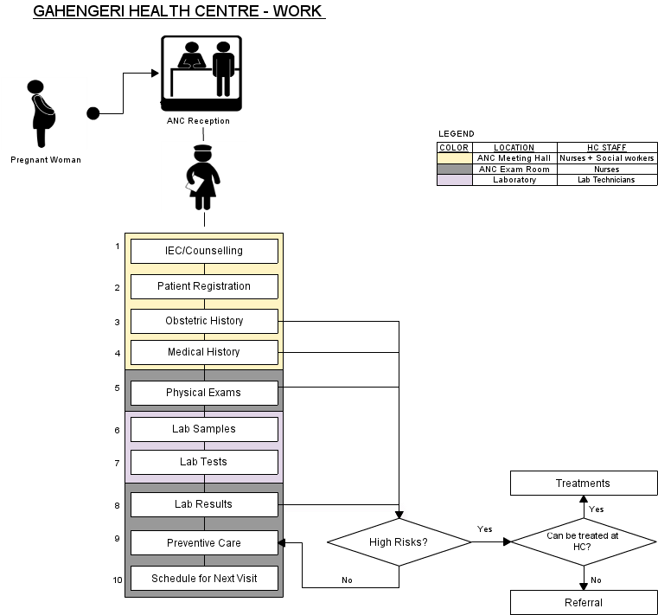

ANC clinic workflow description:

This is a relatively new health centre. They have a big room in which they register women and get a medical history – they fill in first page of ANC forms. Registration is carried out by the nurses. There is a small room on the side of the meeting room where women are given physical exams. After their physical exam women are sent to the Lab where samples are taken. Women then go back to the exam room to receive results, treatment/referral and schedule follow up appointments.

Encounter description:

FIRST VISIT | OTHER VISITS | DESCRIPTION
IEC/COUNSELLING |  | Information, Education Communication about Family Planning, HIV/AIDS, parenting, Breastfeeding...
PATIENT REGISTRATION |  | Filling the Demographics of the Pregnant Woman (names, address – Village/Cell Sector/District, Patient number, Partner's name, Date of birth,..)
OBSTETRIC HISTORY |  | Number of previous pregnancies, date & outcome of each event, special maternal complications & events in previous pregnancies, birth weights, obstetrical operations, special perinatal complications and events in previous pregnancies,...
MEDICAL HISTORY |  | Specific diseases & complications (Tuberculosis, heart diseases, chronic renal diseases, epilepsy, dibetes, high blood pressure, asthma, HIV/AIDS...)
PHYSICAL EXAMS | PHYSICAL EXAMS | Physical exams include (height & height, incremental weight gains, blood pressure, edema, breasts, severe anemia, temperature, uterine height, child heartbeat, ...)
LAB SAMPLES | LAB SAMPLES | Blood  Urine
LAB TESTS | LAB TESTS | - Blood: HIV/AIDS, Syphilis (RPR), Haemoglobin (Hb) in case of severe anemia  - Urine: Albumin,
LAB RESULTS | LAB RESULTS | These are the results of the lab tests.
PREVENTIVE CARE | PREVENTIVE CARE | These include: malaria prevention (Mosquito nets, sufadixine/pyrimetamine) Tetanus vaccinations, Iron & folate supplements, De-worming tablets (Mebendazole)
TREATMENTS | TREATMENTS | This happens in case of high risk complications that can be treated at the health centre
REFERRALS | REFERRALS | This happens in case of high risk complications that cannot be treated at the health centre
SCHEDULE NEXT VISIT | SCHEDULE NEXT VISIT

ANC Patient Registration and records
Person responsible for registering patients at clinic: ANC Nurse
Registration process:
Patient records accessed prior to consultation: ANC Nurse
Patient medical history tracked: Manually on Forms and Registers
Type of forms used to collect patient information: ANC Form, ANC Register, ANC Maternal Card, PMTCT Liaison Form
Person responsible for completing patient records: ANC Nurse
Patient records stored: ANC Exam Room
People with access to patient records and reasons for access:
- ANC Nurse: Filling, Filing, Scheduling next visits, reference...
- Data Manager: Reporting and checking quality of data,..
- Titulaire: as the overall supervisor of the health centre, in case of referrals, quality assurance of data,...

Infrastructure
Power: GRID
Existing ITC systems at health facility: DHIS-2
Number of existing computers at health facility 6
Number of UPS at health facility 6
Number of printers at health facility 3
Number of existing computers in ANC clinic 0
Number of UPS in ANC clinic 0
Number of printers in ANC clinic 0
Computer maintenance carried out by: IT Manager
LAN: YES
Internet: GPRS (MTN RWANDA)
Secure room/station in ANC for computer: ANC Meeting Hall (Yes), ANC Exam Room (Yes)

IT skills assessment

Beginner 50%

Average 17%

Advanced 33%

