Avega Health Centre - Site Assessment

General Health Facility Information
Address:
Manager details: Tel: 0788626706
Email: c.s_avegargna@yahoo.fr
Primary contact person: MUKAMUYENZI Judith (Titulaire)
Type of health facility: Health Centre
Catchment population: 14,922
Primary referral site: RWAMAGANA DISTRICT HOSPITAL
Distance from main road: 0.2 KM
Total staff: 23
Total clinical staff: 8
Total number of IT staff: 3
Services are offered: Primary Curative Consultation, ANC, Vaccination, Family Planning, HIV (ARV, PMTCT, VCT), Maternity, Integrated Management of Childhood Illnesses (IMCI), Laboratory
Names of projects/programmes currently involved in: Global Fund

Antenatal Care
Location of ANC clinic: SEPARATE CLINC SITE
Number of ANC clinics per week: 2
Days of ANC clinics: TUESDAY (FIRST VISITS) FRIDAY (OTHER VISITS)
Total Maternity/ ANC clinical staff: 8
Number of new ANC visits per month: 45
Number of deliveries per month: (MATERNITY STARTED IN MAY 2012).
Number of case transfers/referrals per month: 0
Number of case transfers/referrals by ambulance per month: 45

ANC clinic workflow diagram:

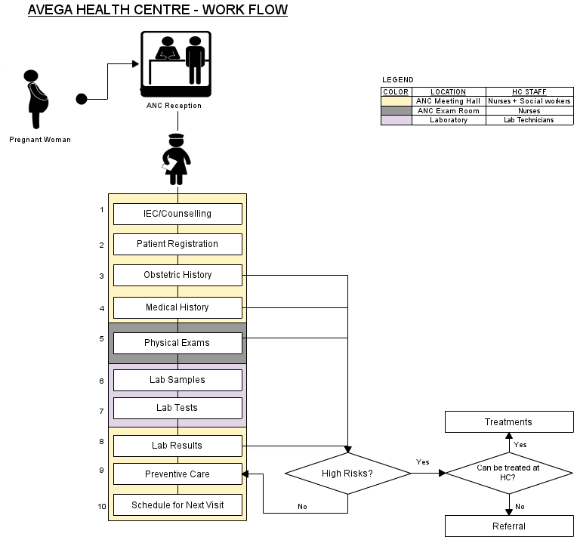
ANC clinic workflow description:
Outside area for waiting where everyone gathers before clinic. Then clinic opens and women go into hall as a group for education, registration and waiting exam. Issue of confidenciality in taking health info in big room – registration happens at front desk where conversation can not be hear by the whole room. Head of ANC coordinates clinic and assigns staff to tasks. Education conducted by nurse who are supported by social workers. Regristration and histrories are taken nurses. At the same time blood pressure, weight etc are taken from women. The women are then taken into exam room for physical exam. Women are then sent to lab for taking samples and come back to the hall and wait for results. When results come in women are called to the desk to receive treatment and schedule next visit. If women test positive for HIV they are referred to counciling with their partners.

The hall used for the ANC clinic reception is a multi purpose hall which is also used for other clinics. This is where the computer(S) would be house as the exam room is very small, only space for a bed and chair. The hall currently has LAN and locks.

ANC visit process:

FIRST VISIT | OTHER VISITS | DESCRIPTION
IEC/COUNSELLING |  | Information, Education Communication about Family Planning, HIV/AIDS, parenting, Breastfeeding...
PATIENT REGISTRATION |  | Filling the Demographics of the Pregnant Woman (names, address – Village/Cell Sector/District, Patient number, Partner's name, Date of birth,..)
OBSTETRIC HISTORY |  | Number of previous pregnancies, date & outcome of each event, special maternal complications & events in previous pregnancies, birth weights, obstetrical operations, special perinatal complications and events in previous pregnancies,...
MEDICAL HISTORY |  | Specific diseases & complications (Tuberculosis, heart diseases, chronic renal diseases, epilepsy, dibetes, high blood pressure, asthma, HIV/AIDS...)
PHYSICAL EXAMS | PHYSICAL EXAMS | Physical exams include (height & height, incremental weight gains, blood pressure, edema, breasts, severe anemia, temperature, uterine height, child heartbeat, ...)
LAB SAMPLES | LAB SAMPLES | - Blood  - Urine
LAB TESTS | LAB TESTS | - Blood: HIV/AIDS, Syphilis (RPR), Haemoglobin (Hb) in case of severe anemia  - Urine: Albumin,
LAB RESULTS | LAB RESULTS | These are the results of the lab tests.
PREVENTIVE CARE | PREVENTIVE CARE | These include: malaria prevention (Mosquito nets, sufadixine/pyrimetamine) Tetanus vaccinations, Iron & folate supplements, De-worming tablets (Mebendazole)
TREATMENTS | TREATMENTS | This happens in case of high risk complications that can be treated at the health centre
REFERRALS | REFERRALS | This happens in case of high risk complications that cannot be treated at the health centre
SCHEDULE NEXT VISIT | SCHEDULE NEXT VISIT

ANC Patient Registration and records
Person responsible for registering patients at clinic: ANC Nurse
Registration process: see diagram and table above.
Patient records accessed prior to consultation: ANC Nurse
Patient medical history tracked: Forms and Registers
Type of forms used to collect patient information: ANC Form, ANC Register, ANC Maternal Card, PMTCT Liaison Form
Person responsible for completing patient records: ANC Nurse
Patient records stored: ANC Communal Hall
People with access to patient records and reasons for access:
- ANC Nurse: Filling, Filing, Scheduling next visits, reference...
- Data Manager: Reporting and checking quality of data,..
- Titulaire: as the overall supervisor of the health centre, in case of referrals, quality assurance of data,...

Infrastructure
Power: GRID
Existing ITC systems at health facility: DHIS-2
Number of existing computers at health facility 5
Number of UPS at health facility 5
Number of printers at health facility 1
Number of existing computers in ANC clinic 0
Number of UPS in ANC clinic 0
Number of printers in ANC clinic 0
Computer maintenance carried out by: IT Manager
LAN: YES
Internet: GPRS (MTN RWANDA)
Secure room/station in ANC for computer: ANC Meeting Hall (Yes), ANC Exam Room (too small, no LAN)

IT skills assessment

Beginner 68%

Average 32%

Advanced 0%

