RHEA Business Architecture   
(Draft – 4/20/2012)

This high-level Business Architecture uses Archimate diagramming techniques to provide information about the Rwanda Health Enterprise Architecture (RHEA). (See below for a brief discussion of Archimate.  
  
That architecture defines the different functional areas in which healthcare data processing is required. It is focused on the systems to be specified and implemented on a national level through the RHEA project. It shows how the different types of care and service delivery are supported by the common services of the National Registries.  
  
The RHEA Business Architecture diagram shows the services required for healthcare delivery as specified within the Rwanda National e-Health Strategic Plan. In order for these services to function efficiently at the highest level, and in order for them to work together, the RHEA project has a) defined a set of national registries to manage the common data needed to support healthcare delivery, b) created a National Data Warehouse and Shared Health Record to serve as common repositories for patient care and other relevant information, c) implemented a service - the Interoperability Layer - that will initially support the data exchange needed to access the national registries and repositories. As the system develops, the Interoperability Layer will also provide a common and consistent platform for data exchange between individual health care delivery systems.

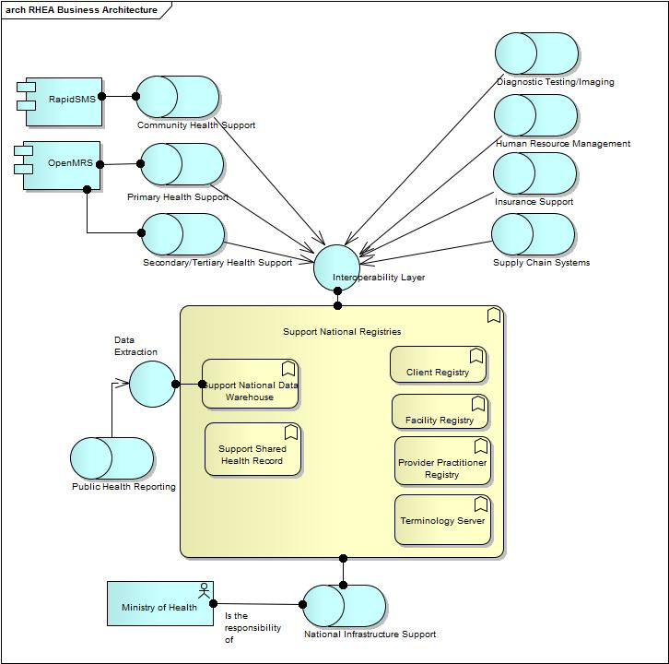

Figure 1 : RHEA Business Architecture

### Support National Registries

The National Registry Service includes access to the common resources whose use ensures the consistency of the information used by the different organizations within Rwanda's health sector.

### Client Registry

The management and provision of access to identifying and demographic information for persons who receive healthcare services within Rwanda.

### Facility Registry

A site/server/capability that is capable of managing the identity and related information for health care provider facilities - and associated resources.   
  
Such a system can be used as a reference file to validate the identity of a facility and to associate it with a location. An additional set of capabilities would be to support resource referrals, and resource scheduling.  
  
The facility registry must also record the location of the individual facility.  
  
There are two distinct levels of requirements. The first is to identify the various significant locations, e.g., health care provider, warehouse, village, and to provide geographic coordinates so that spatial relationships can be managed. The second is to identify regions, and to locate places within regions to support creation of maps and to allow summary reporting based on geographic entities.

### Provider Practitioner Registry

A site/server/capability that is capable of managing the identity and related information for health care providers (aka practitioners). The information managed will include their specialties and associated capabilities.   
  
Such a system can be used as a reference file to validate the identity of a provider or practitioner and to associate them with a facility or facilities. An additional set of capabilities would be to support resource referrals, and resource scheduling.

### Support National Data Warehouse

A repository to hold and make available information generated by the other components. It will often include facilities to support reporting and ad hoc queries.

### Support Shared Health Record

The Shared Health Record service provides access to clinical data that has been recorded for patients within the health care system, and accepts updates to and corrections of that data.

### Terminology Server

A site/server/capability that is capable of managing the different code systems and value sets (vocabulary) that are needed to support processing by the system and its components.  
  
It should be a repository for the different vocabularies (code sets) that are used, and also support the need of systems for updated vocabularies when the list of valid codes changes.

### RHEA Business Architecture:Community Health Support

There are several healthcare interventions that are offered at a community level, mainly by Community Health Workers. This cadre of volunteer health workers is estimated to be around 30,000 in nearly every village in the country and is expected to double within the  
next few years.  
  
Some of the activities that are carried out by the community workers include:  
Sensitizing the population on the benefits of health Mutuelle membership, family planning, hygiene, prevention of HIV/AIDS and malaria;  
Supplying bed-nets, contraceptives and ORS/zinc to prevent dehydration in children with diarrhea;  
•Distributing anti-malarials, antipyretics, and other medicines to treat respiratory infections and diarrhea;  
•Sensitizing pregnant women to attend ante-natal consultations (ANC), to deliver in health facilities and to have their children vaccinated;  
Track and report on vital events in the village, in particular births and maternal and child deaths.  
  
One of the key functions of community health workers is to collect and report data related to maternal child health and surveillance indicators.

### RHEA Business Architecture:Diagnostic Testing/Imaging

Laboratory services can be enhanced by using appropriate information systems that support these services. The automation of laboratory helps in reducing unnecessary repetition of such diagnostic tests and facilitates sharing of results.  
  
Diagnostic images and their interpretation are of high clinical value. However, their availability is constrained by the high capital and operating cost associated with imaging modalities and by the scarcity of the highly skilled health professionals who support diagnostic imaging services. It is therefore essential that Rwanda makes the best use of what information technology can afford by extracting the most clinical value possible from its imaging services.

### RHEA Business Architecture:Human Resource Management

Human resource management is key to an improved healthcare system. There is a need for decision makers to know the available human resource in the country, their different levels of training, distribution, production from teaching institutions and the required training, etc.

### RHEA Business Architecture:Insurance Support

Health Insurance plays an important role in healthcare provision. It enhances financial accessibility to healthcare services. In Rwanda there are mainly two public healthcare insurance schemes; RAMA and Mutuelle de Santé. More than 80% of Rwandan citizens have health insurance coverage. The Government aims at providing healthcare insurance to all citizens by the end of the year 2009. There is a need to automate healthcare insurance services. This will facilitate citizens in receiving healthcare services from all parts of the country and will provide seamless healthcare claims and processing.

### RHEA Business Architecture:Ministry of Health

The Ministry of Health is the government organization responsible for supervising healthcare delivery within national borders. It is the sponsor, and the responsible party for creation and organization of the National Infrastructure Support function.

### RHEA Business Architecture:National Infrastructure Support

The infrastructure support role aims to meet Rwanda's eHealth goals as expressed by the Ministry of Health.  
  
To Use Information and Communications Technologies to Provide and Support Healthcare service delivery.  
This definition encompasses an integrated set of information systems that enable the following:

* Efficient delivery of healthcare services over the full continuum of care through the provision of integrated, interoperable health information systems, tools and processes;
* Transformed health sector decision-making culture into one that is firmly supported by accurate, timely and relevant information in a manner that protects individual privacy, respects clinical practice requirements and sustains the long term viability of the healthcare system; and
* A clearly defined architecture and standards for integrated and interoperable e-Health systems with defined standards.

### RHEA Business Architecture:Primary Health Support

Primary care is the foundation of Rwanda’s healthcare system. For most Rwandans, it is the first and most frequent point of contact with the healthcare system. It may include, for example, consultation at health centers, care by a midwife or nurse practitioner, or a visit to a private clinic.   
  
Primary care is the component where most new health problems are identified and addressed, and where patients and providers work together to prevent and/or manage most diseases. In Rwanda, the most common place to receive primary care is at primary health centers.

### RHEA Business Architecture:Public Health Reporting

Public health is “the science and art of promoting health, preventing disease, prolonging life and improving quality of life through the organized efforts of society.” Public health is largely synonymous with the population health approach. It includes health surveillance as an integral part of disease prevention and control, and uses its information  
products to evaluate, develop and guide health policy and programs. Public health requires the timely sharing of information among health authorities.   
  
A public health approach is sensitive to the determinants of health — the factors or conditions that affect health status (e.g. income and social status, education and literacy, employment/working conditions, social and physical environments) — and includes processes and multiple strategies that:  
• focus on the health of a population as a whole;  
• address the determinants/indicators for health and their interactions;  
• base decisions on evidence; and  
• support collaboration across sectors and jurisdictional levels.

### RHEA Business Architecture:Secondary/Tertiary Health Support

AKA Hospital Management Information System  
  
Acute care is a level of care in which a patient is treated for a brief but usually severe episode of illness, for conditions that are the result of serious disease or trauma, and during recovery from surgery. Acute care is generally provided in a hospital by a variety of clinical personnel using highly technical equipment, pharmaceuticals, and other medical supplies. In Rwanda acute care is provided in district hospitals and referral hospitals.  
  
Most acute care hospitals across the Country include emergency services, surgical programs, medical treatment programs, laboratory services, diagnostic imaging and outpatient clinics. Each hospital may also have its own specialty programs, depending on the needs of the population it serves (e.g. maternity, pediatrics, psychiatry). Referral  
hospitals offer more specialized services such as tertiary trauma care, cardiology, neurology, oncology or thoracic surgery.

### RHEA Business Architecture:Supply Chain Systems

Procurement, supply and tracking of drugs and consumables are critical functions of the healthcare system. Automation of these processes leads to improved stock management, reduces drug expiry and reduces the cost of delivering to the consumers among may other benefits.  
  
There is need for a networked linkage between pharmacies in all health facilities into a central system. Coupled with pharmacy management systems at hospitals and health centers the systems will provide data and services to support drug distribution, dispensing. Key benefits of drug procurement and tracking system and healthcare facility pharmacy  
management systems are:  
Proper distribution of drugs to where the need for a particular drug is;  
Expiry dates and stock situation alerts for better inventory management;  
Prevention of inappropriate therapies by enabling drug interaction and dosage range checking;  
Prevention of over consumption of prescription drugs by unintended duplication or fraud;  
Promotion of cost effective usage of drugs and other therapeutic alternatives;  
Improvement in standards of practice by offering comprehensive drug  
information and complete patient medication information.  
  
Note that the primary focus of the discussion is on pharmacy. However, supply chain requirements go beyond pharmacy, and there are aspects to addressing pharmacy information that go beyond the supply chain.

### RHEA Business Architecture:OpenMRS

The OpenMRS patient management system has been chosen as the application to support the patient care needs of primary health sites. An OpenMRS system is installed or to be installed at individual primary health centers. The rollout of this system is currently underway.

### RHEA Business Architecture:RapidSMS

The RapidSMS application provides a single point of contact for receiving care and managing information that is provided by community health workers. Communication between the individual community health worker and the RapidSMS system takes place via cell phone.

### RHEA Business Architecture:Data Extraction

The National Data Warehouse has to provide an interface that supports the query or queries that are used to extract data needed for public health reporting.

### RHEA Business Architecture:Interoperability Layer

The Interoperability Layer provides an appropriate interface to allow access to the information managed by the various national registries. There are three key functions that are performed:  
  
a) Transaction Management: Accepting transactions from local health systems and routing them to the appropriate national system. It also provides a guarantee of message integrity from the time of receipt until a response is returned, and maintains logs of received messages to facilitate error checking and backup.  
  
b) Translation Capability: It is intended that a single set of nationally chosen standards will be used to define the format and vocabulary content of received messages. However, variability in the way data is supplied cannot be eliminated. This is especially true for vocabulary items. In addition, since data requirements evolve, there will be a periodic need to migrate from one version of a standard to the next. The Interoperability layer has the responsibility of accepting data as provided from individual senders, and translating or recasting it in a single form for consumption by the national registries and other systems.  
  
c) Data Validation: In many cases, a message sent to one registry will refer to data maintained by another. For example, the record of clinical care provided by a healthcare facility to the Shared Health Record contains references to the patient (managed in the Client Registry), to the attending healthcare professional (managed in the Client Registry), to the responsible facility (managed in the Facility Registry), and to various clinical vocabularies (managed in the Terminology Server). The Interoperability Layer will create and send the necessary validation queries to check on these references, and it will create the necessary response going back to the original sender.  
  
A more detailed look at the architecture will show this single interface split into several, more specialized ones.

# Working with Archimate

ArchiMate [Ahr-ki-meyt] is an open and independent [enterprise architecture](http://en.wikipedia.org/wiki/Enterprise_architecture) [modeling language](http://en.wikipedia.org/wiki/Modeling_language) to support the description, analysis and visualization of architecture within and across [business](http://en.wikipedia.org/wiki/Business) domains in an unambiguous way. ArchiMate is a technical standard from the [Open Group](http://en.wikipedia.org/wiki/Open_Group) and is based on the concepts of the [IEEE 1471](http://en.wikipedia.org/wiki/IEEE_1471) standard. It is supported by various tool vendors and consulting firms. ArchiMate is also a registered trademark of The Open Group.

Just like an architectural drawing in classical building architecture describes the various aspects of the construction and use of a building, ArchiMate offers a common language for describing the construction and operation of [business processes](http://en.wikipedia.org/wiki/Business_processes), organizational structures, [information flows](http://en.wikipedia.org/wiki/Information_flow), IT systems, and technical infrastructure. This insight helps the different [stakeholders](http://en.wikipedia.org/wiki/Project_stakeholder) to design, assess, and communicate the consequences of decisions and changes within and between these business domains.

An [architecture framework](http://en.wikipedia.org/wiki/Architecture_framework) is used to structure the concepts and relationships of the ArchiMate language. It divides the [enterprise architecture](http://en.wikipedia.org/wiki/Enterprise_architecture) in to a business, application and technology layer. In each layer, three aspects are considered: active elements that exhibit [behavior](http://en.wikipedia.org/wiki/Behavior) (e.g. Process and Function), an internal [structure](http://en.wikipedia.org/wiki/Structure) and elements that define use or communicate [information](http://en.wikipedia.org/wiki/Information).

One of the objectives of the ArchiMate language is to define the relationships between concepts in different architecture domains. The concepts of this language therefore hold the middle between the detailed concepts, that are used for modeling individual domains, for example, the [UML](http://en.wikipedia.org/wiki/Unified_Modeling_Language) for modeling [software](http://en.wikipedia.org/wiki/Software) products, and [BPMN](http://en.wikipedia.org/wiki/BPMN) which is used for business process modeling.

Modeling for RHEA has used a subset of the diagramming objects defined in Archimate. These are briefly introduced in the diagram:

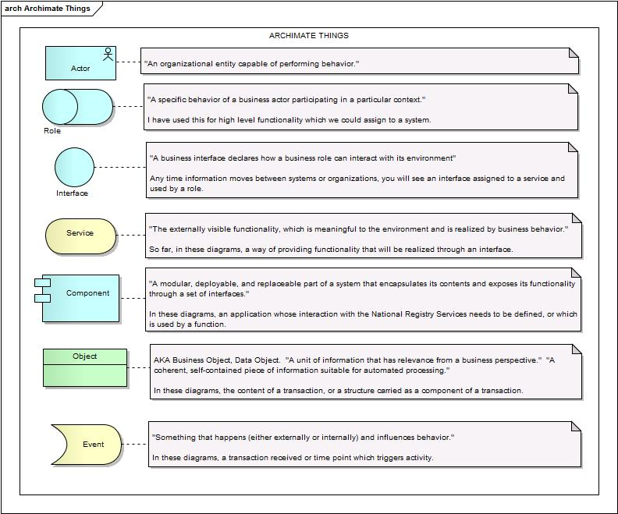

Figure 2 : Archimate Things

Similarly, only a subset of the associations between diagramming objects have been used. That subset is contained below:

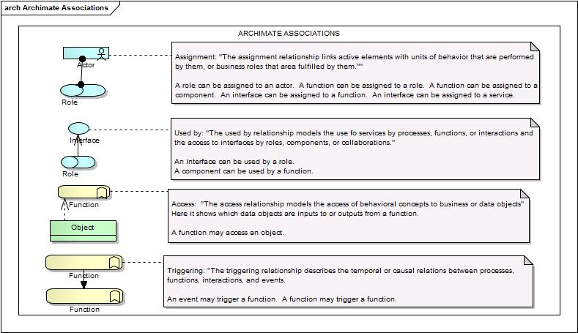

Figure 3 : Archimate Associations

This is clearly an inadequate introduction to Archimate modeling. For more information the reader should refer to the site: [www3.opengroup.org/subjectareas/enterprise/archimate](http://www.opengroup.org/subjectareas/enterprise/archimate).

# RHEA Project 2012

Within the overall architecture, it is necessary to focus on the RHEA related projects currently being worked on. This section addresses the two projects active within Rwanda during 2011, and 2012: 1) using the national registries to provide improved support for Maternal and Child Health. 2) implementing a national Facility Registry to provide a single point of contact for managing facility information. It is expected that work on the provider/health care professional register will be taken up next.

## Maternal & Child Health Project

Currently, the RHEA team is developing architecture components in the context of a project to improve maternal & child health. The goal is to both get pieces of the design implemented and to demonstrate the usefulness of the architecture.   
  
The RHEA Phase 1 Implementation project aims to evaluate a need in Rwanda to improve interoperability and access to standards and foundational terminologies and services for implementers of eHealth and health information systems. This will be achieved by implementing the RHEA foundational components in a localized setting to address a focused health concern. The plan is for the pilot application stack to serve as an evolutionary prototype that, should it prove successful, in subsequent phases, will transition into a working system that can support health delivery country wide.  
The plan, in phase one, is to implement the foundational components (patient registry, provider registry, facility registry, terminology services and a shared health record) all loaded with the national data (where it is available- and our understanding is that it is available for the all 3 registries). These foundational components will then be connected to at least 2 Point of Care (POC) applications (OpenMRS and RapidSMS application) via a limited-function interoperability “layer” or protocol which will use a standard predefined messaging format. In phase two of the project, a more robust and extended health information access layer will be implemented in order to provide a standard interface to other applications. Phase two is out of scope for the present pilot implementation project (although the simplified “interoperability layer” will be in scope).  
  
This will be implemented in a pilot area that will include a single district, with up to 5 primary health facilities in that district. The pilot will be limited to maternal care (antenatal care, delivery and postpartum follow up) as well as the entry of the baby into the system (including registration into the patient/client registry).  
Although all data will be loaded from the national systems already in existence, if there is any required verification and cleaning of the data (including the entry of additional fields etc) it will only be done for the geographical area in scope. Connections to hospital systems are out of scope for the pilot.  
  
The diagram provides a view on this activity.

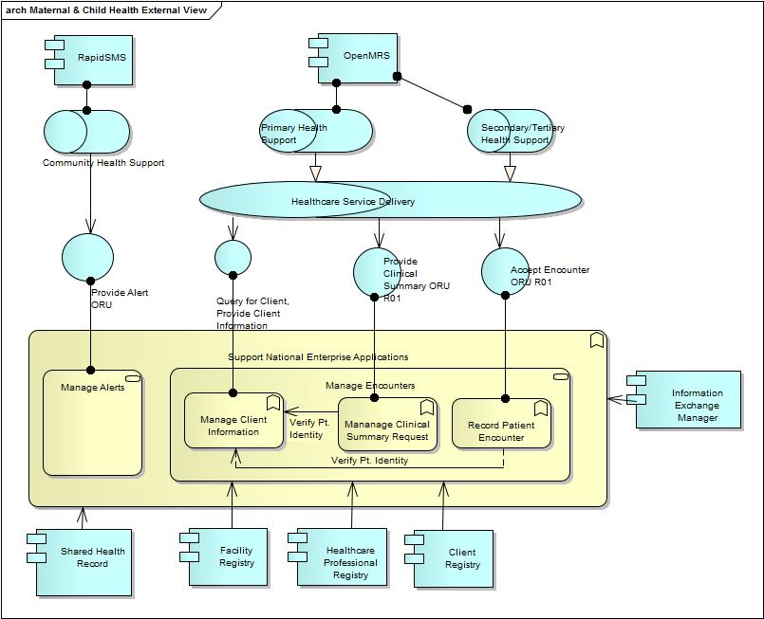

Figure 4 : Maternal & Child Health External View

### RHEA Interoperability Layer

The Interoperability Layer provides the glue that links and supports the national systems. It provides access to the national registries, and implements the common functions, e.g., security, transaction logging that are needed to support the functioning of the registries.   
  
Access to registry information, for example to client information managed by the Client Registry - is controlled by the "Messaging Layer" (AKA Information Exchange Manager). This process includes verifying the right to access this information, identifying the client whose data is being requested, and formatting of the data.  
  
Similarly, when data within Shared Health Record needs to be accessed, the request is received by the Interoperability Layer, which manages the processing needed to validate access to the data, and to verify the accuracy of relevant data managed within the Facility, Provider, and client Registries. The Interoperability Layer also controls the processing needed to validate coded items - vocabularies - received within messages through interchange with the Terminology Service.

### Manage Alerts

The evaluation of clinical data to determine the need for sending a clinical alert, and the formatting of the needed outbound transactions. There are many situations that indicate the need for attention on the part of healthcare professionals, and correspondingly, there are many ways that data may be queried in order to substantiate the need to send an alert message.  
  
Work on Maternal and Child Health for the RHEA project has developed a list of reminder and advice messages. These include such items as:  
  
Provide a notification to the community health worker 14 days before a woman's expected delivery date.  
  
Provide a notification to a community health worker and to the ambulance service, if, according to risk assessment based on clinical information in the Shared Health Record regarding the woman's condition, the woman needs to deliver in hospital.

### Manage Client Information

Managing client information is a function carried on within the interoperability layer, that controls communication with the Client Registry. The goal is a) to get client ID verified when client information is carried within a message, b) to retrieve client information when needed, and c) to pass on new client information for updates to current clients or for creating new client records.

### Manage Encounters

The management of patient encounters includes two related scenarios:  
  
1. Clinical summary data is provided to healthcare professionals who are treating patients. This information is requested by the professional when needed to provide the context for managing the patient. Within the clinic setting, in which a record of each encounter is being captured by the Shared Health Record, the clinical summary request/response is processed at the beginning of the encounter to allow validation of relevant information, and to ensure that clinical data is available during the encounter. Within the hospital setting - from which encounter information is not currently to be provided - the function is triggered by the professional when needed.  
  
2. A message that includes data from the current encounter is generated by a participating facility at the end of the encounter. It includes the relevant data collected by the healthcare professional in the course of the encounter.  
  
Loading and updating the facility, healthcare professional and client registries is an essential support activity for these scenarios. Loading those vocabularies that are used to support maternal and child health are similarly necessary.

### Maternal & Child Health Project:Healthcare Service Delivery

The delivery of direct patient care to patients. This generalization of primary, secondary, and tertiary health support is introduced because of the common interfaces that the different levels of health delivery must use to exchange data.

### Maternal & Child Health Project:Accept Encounter ORU R01

New encounter data is used to update the client registry and the shared health record. This is accomplished by accepting HL7 V2.5 ORU (observation report unsolicited) transactions.

### Maternal & Child Health Project:Provide Alert ORU

Data stored within the shared health record is evaluated to generate alerts in order to provide relevant information to community health workers. Alerts are provided using the HL7 V2.5 ORU (Observation Report Unsolicited) format.

### Maternal & Child Health Project:Provide Clinical Summary ORU R01

The clinical summary - the key information that has been captured from previous health care encounters - will be used by clinicians within both the primary and secondary health care facilities to improve the care delivered to patients.

### Maternal & Child Health Project:Query for Client, Provide Client Information

## Alert Management

The creation of clinical alerts and, more broadly, clinical decision support is an important component of the RHEA vision. However, it is important to note that, from the perspective of the RHEA National Systems, the focus is on those items stored within the Shared Health Record that are important to communicate to other systems, that is, to systems other than the one that generated the data. Generation of clinical alerts using data stored locally is a responsibility of the local Point of Care systems.  
  
Data is provided to the Shared Health Record to become part  
of the patient’s record, and to be available for use at primary health centers and district hospitals. At the same time, this data may be used to trigger alerts that provide relevant information to community health workers and other healthcare providers.

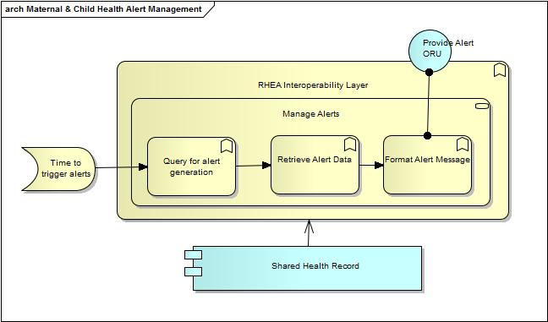

Figure 5 : Maternal & Child Health Alert Management

### Format Alert Message

Once the needed data is retrieved, it is organized into the specified HL7 V2.5 message specification in order to be transmitted to the defined recipient or recipients.

### Query for alert generation

When the system is notified of the potential for creating an alert, the Shared Health Record is queried to determine whether, given the data collected for current clients, creation and transmission of alerts is indicated.

### Retrieve Alert Data

Given the need for one or more alerts to be sent, the data needed for each alert is retrieved from the Shared Health Record.

### Time to trigger alerts

Alert processing can be triggered in two ways, by date, and by receipt of information.  
  
A number of alerts are based on comparing the current date, to the date of an expected activity. For example RHEA expects a community health worker to be notified of the need for an antenatal care visit a specified number of days before the woman's expected delivery date. (The goal is to achieve a desired number of antenatal visits to the clinic.)  
  
An alert may also be triggered by the receipt of new information. For example, receiving a message from a community health worker (or clinic health care professional) regarding a condition defined as a serious risk to mother or fetus, may trigger a message or messages with the object of having the mother deliver her child at a hospital as opposed to a health center.

## Encounter Management

The RHEA architecture stipulates that the key information from a patient encounter be stored within the Shared Health Record, and that the information be made available when needed to support patient care.  
  
The functionality involved is managed within two scenarios.  
  
Manage Encounters: The processing required when a patient appears at a healthcare provider. Information for the encounter needs to be recorded, and summary information used to guide patient care needs to be returned to the clinical site.  
  
Request Clinical Summary: A healthcare professional may need to access data on a patient in a situation outside of the direct providing of encounter information.

### Application Security Verification

An incoming transaction is examined to ensure its validity. If the sending system has been registered as a valid RHEA site, the transaction will be accepted.  
  
At a future time, it is expected that more finely grained access control will be implemented. However, currently, the only checking will be for the validity of the sending system.

### Log Transaction Activity

A transaction that is received from a client application must be logged before validation or further processing. The log can be used to reprocess data in case of system failure, or for debugging in cases where the data are not processed as expected.   
  
Transactions to be sent to clients must be logged as well.

### Manage Clinical Summary Request

A request for a clinical summary is also a request to validate the facility, healthcare professional, and patient identifiers that have been provided. This ensures the request is valid. In addition, when the request is received at the beginning of an encounter for which data will be provided to the Shared Health Record, it eases the validation task for that data interchange.  
  
Currently, the clinical summary is provided by passing a list of relevant encounters. Note this list includes all the encounter data originally passed to the Shared Health Record. The clinical summary query can be constrained by indicating the time period the desired encounters fall into.  
  
Note, the function depends on the Manage Client Information Function to verify the client's identity, and to return client specific information.

### Collect Information for Clinical Summary

Once verification of reference data is complete, the relevant data for the clinical summary is retrieved from the Shared Health Record.

### Format Encounter List Response

The retrieved information is formatted into the appropriate HL7 message - ORU_R01 - for transmission to the requesting provider.

### Record Patient Encounter

Those facilities that are directly participating in the Maternal & Child project will provide encounter information for storage within the Shared Health Record. This information becomes part of the patient's longitudinal record.  
  
Facility, healthcare professional, and patient identifiers are validated for the receipt of this information, even though that validation will also have taken place at the initiation of the encounter.  
  
Note, the function depends on the Manage Client Information Function to verify the client's identity, and to allow the updating of client specific information.

### Record Encounter

Once facility, healthcare professional, and client information have been validated for a new encounter, the data collected within the encounter needs to be recorded within the Shared Health Record.

### Update client Information

The information received for an encounter may also include new or revised information on the patient (aka client). When this happens the Client Registry must be updated.

### Verify Facility

The record of an encounter always includes the identifier of the responsible facility. That identifier is validated against the Facility Registry.  
  
Note, the mechanics of the validation is handled by the Information Exchange Manager and is transparent to the sending facility.

### Shared Health Record Management

The Shared Health Record management application supports an interface that allows the Information Exchange Manager to provide updates to patient information, and to retrieve that information when it is requested.

### Encounter Management:Accept Response (HTTP 200)

If the received message passes validation - if the supplied identifiers for facility, healthcare professional, or patient are valid - an accept response is sent to the sender of the original clinical message.

### Encounter Management:Activity Record

A record of the data structure received from a client application, or about to be transmitted to one.

### Encounter Management:Bad Request (HTTP 401)

The error response is sent if the client cannot be identified - if no matching client is found, or if there are multiple clients found.  
  
Note, in the future it is expected that discovery of multiple clients will trigger a response to the sending system conveying a list of clients to be chosen from. For the initial delivery, this will be treated as an error.

### Encounter Management:Invalid Access Message

A notification that the requesting application does not have permission to access RHEA data stores.

## Client Information Management

The folder contains the functionality that is specifically needed to address requests for client information, as well as other requests or updates that require validating client identity.

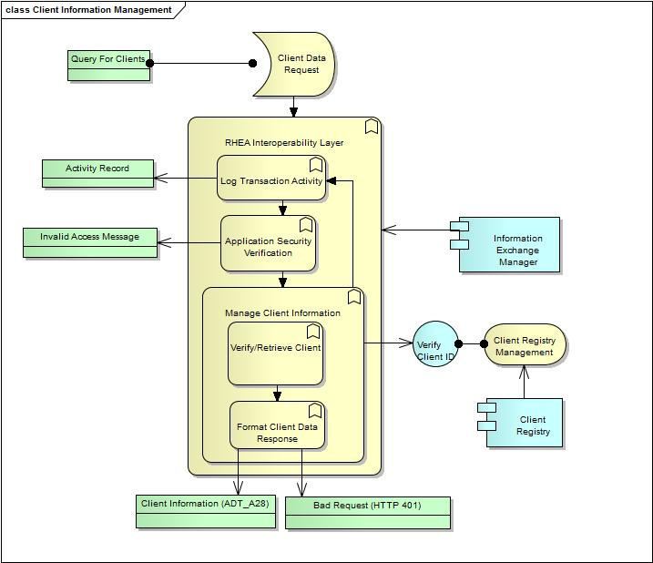

Figure 6: Client Information Management

### Client Data Request

The trigger for processing is the receipt of the Query for Clients message.

### Client Registry Management

Client information management is an umbrella function that includes the ability to update and store client information, as well as providing client information when requested, and responding to queries aimed at verifying client identity.

### Format Client Data Response

Once a client record has been searched for - either successfully or not - the data returned needs to be formatted for transmission to the original message sender.

### Verify/Retrieve Client

Data received in transactions will be used to determine whether the identifying information that was provided actually corresponds to a record within the Client Registry. If there is a match, either confirmation of identity, or relevant client information will be returned.  
  
Note, for the initial implementation, the retrieval of multiple client records is treated as an error.

### Client Information Management:Activity Record

A record of the data structure received from a client application, or about to be transmitted to one. The record goes into the transaction log of all activity managed by the Interoperability Layer. It is used for debugging, and recovery from failures of various types.

### Client Information Management:Client Information (ADT_A28)

The message will contain identifying and demographic information for the client.

### Client Information Management:Query For Clients

The query for clients may include one or more identifiers as well as demographic information, e.g., name, address, date of birth, for the client.

### Client Information Management:Client Registry

The Client Registry is a system (component) that provides access to demographic and identifying information that has been recorded for patients within the health care system, and accepts updates to and corrections of that data.

### Client Information Management:Verify Client ID

The client registry management application supports an interface that is only exposed to the Information Exchange Manager. The interface can respond to queries aimed at verifying client identity, and/or retrieving client information.

## Clinical Data Management

This folder contains elements that are specifically related to retrieving clinical information - stored in the Shared Health Record - for a patient. This process requires that client identity be validated within the Client Registry, as well as including client demographic details stored within the Client Registry.  
  
Currently, the data that will be retrieved is presented as an ordered collection of patient encounters. The organization and content of the data returned will mirror the way it was provided when encounter data was stored in the Shared Health Record. It is expected that, at a future date, information structures that are particularly important for understanding the status of the patient will be presented so as to illuminate the patient's current condition.

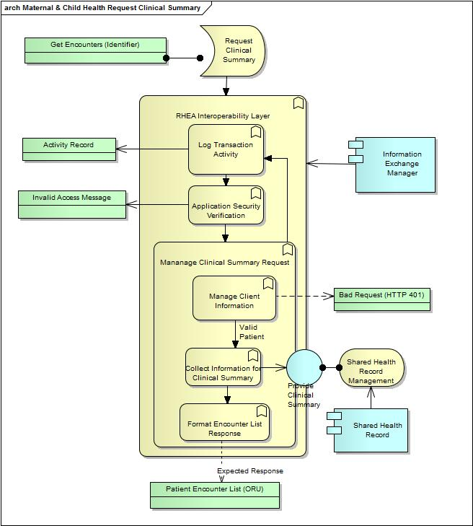

Figure 7 : Maternal & Child Health Request Clinical Summary

### Request Clinical Summary

A request for the clinical summary of a treated patient is received. This is the first step in managing an encounter whose data will be stored within the Shared Health Record

### Clinical Data Management:Get Encounters (Identifier)

The request for encounter information must include a patient identifier, and may also specify a date range for the desired set of encounter.

### Clinical Data Management:Patient Encounter List (ORU)

The transaction includes basic identifying information for the patient, and a list of patient encounters that contains all the clinical data that was communicated to the Shared Health Record for that encounter.

### Clinical Data Management:Provide Clinical Summary

The Shared Health Record application supports a transactional interface that can provide the relevant clinical information when provided a valid client identifier.

## Patient Encounter Management

The folder contains the items that are specifically related to recording information for new patient encounters. This will involve adding data to the Shared Health Record, and may involve updates to the Client Registry.

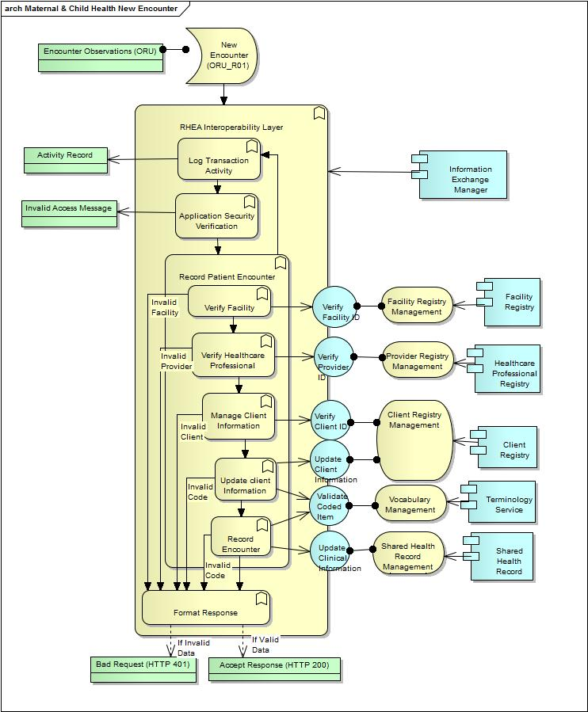

Figure 8 : Maternal & Child Health New Encounter

### Format Response

Create an acknowledgment of the processing of a received message. Note, an HTTP response will be used in place of an HL7 one.

### New Encounter (ORU_R01)

The management of encounter information is triggered by the receipt of an ORU message that contains information on that encounter.  
  
Due to Internet bandwidth and reliability issues, the Rwanda implementation has chosen to limit the number of exchanges between health care provider and the national repositories that is triggered by creation of a patient encounter.

### Provider Registry Management

The healthcare professional registry application supports a transactional interface that can respond to a query regarding whether or not a supplied identifier refers to an existing healthcare professional.

### Verify Healthcare Professional

All encounter transactions are based on a patient's meeting with and/or treatment by a healthcare professional. An important component of validating the message is verification that the healthcare professional referred to in the message is a valid entry in the Healthcare Professional Registry.

### Vocabulary Management

The Vocabulary Management service stores and organizes the different code sets and terminologies that are used to represent concepts relevant to the entire range of functions supported by RHEA.   
  
The service has the ability to validate transaction content against its stored terminologies, to capture the semantic relationships between terms, and to track updates and changes to the collection of supported terms and terminologies.

### Patient Encounter Management:Encounter Observations (ORU)

The clinical information that is generated during an encounter and conveyed to the Shared Health Record is organized as a series of observations. This array of data, once received, is validated and stored within the Shared Health Record.

### Patient Encounter Management:Facility Registry

The Facility Registry is a system (component) that provides access to data that has been recorded for healthcare facilities, and accepts updates to and corrections of that data.

### Patient Encounter Management:Healthcare Professional Registry

The Healthcare Professional Registry is a system (component) that provides access to the information recorded for persons who provide treatment within the healthcare system, and accepts updates to and corrections of that data.

### Patient Encounter Management:Information Exchange Manager

The information exchange management component supports the functions of the Interoperability Layer. It manages reception of incoming transactions, receives and responds to queries, generates outbound transactions while carrying out relevant validation of key data items stored within the national registries.

### Patient Encounter Management:Shared Health Record

The Shared Health Record is a system (component) that provides access to clinical data that has been recorded for patients within the health care system, and accepts updates to and corrections of that data.

### Patient Encounter Management:Terminology Service

The Terminology Service is a system (component) that provides access to the terminologies that are used to control the list of values that are valid for coded data within RHEA transactions.

### Patient Encounter Management:Update Client Information

The client registry management application supports an interface that is only exposed to the Information Exchange Manager. The interface can respond to messages carrying information for new clients or updates to the information recorded for existing clients.

### Patient Encounter Management:Update Clinical Information

The Shared Health Record management application supports an interface that is only exposed to the Information Exchange Manager. The interface can support the addition of encounter information for new or existing patients.

### Patient Encounter Management:Validate Coded Item

The vocabulary management application supports an interface that is only exposed to the Information Exchange Manager. The interface the checking of coded content within transactions to determine if the code is drawn from a code system that is allowed for the particular transaction element the code value appears within.

### Patient Encounter Management:Verify Facility ID

The facility registry management application supports an interface that is only exposed to the Information Exchange Manager. The interface can respond to queries aimed at verifying facility identity, and retrieving facility information.

### Patient Encounter Management:Verify Provider ID

The healthcare professional registry management application supports an interface that is only exposed to the Information Exchange Manager. The interface can respond to queries aimed verifying healthcare identity, and retrieving healthcare professional information.

## RHEA Facility Implementation

The RHEA project undertook to create a facility registry as an urgent demonstration project for 2011. The diagram shows the behaviors which are supported.

Figure 6 : RHEA Facility External View

### Facility Registry Management

Facility registry management includes the processing of new facilities as well as updates to existing facilities. It also includes providing facility information including the creation of relevant displays for direct access, and validating the existence of a facility when referred to in a supported transaction.

### RHEA Facility Implementation:Facility Database

The facility database and supporting application is implemented using ..... (Do we have any design documentation here?)

### RHEA Facility Implementation:Get Facility List

Request for facility information is managed through direct access to the facility management application. The broadcast of facility information uses a custom data structure (XML encoded) that is based on the current facility DBMS schema.

### RHEA Facility Implementation:Update Facility Information

Direct user access to the facility management application allows updating facility information.

### RHEA Facility Implementation:Verify Facility ID

Direct user access to the facility management application allows a user to verify a facility id.

## RHEA Provider Implementation

This is a placeholder for now. It will address the functionality provided by the RHEA Provider/Practitioner registry.