Use Case Specification: UCXX: SHR receives PRE message from Rapid SMS

Version 1.0

Revisions History

Date | Version | Description | Author
<dd/mmm/yyyy> | <x.x> | <details> | <name>

Table of contents

1. Nome do Caso de Uso Error! Bookmark not defined.
1.1 Breve descrição Error! Bookmark not defined.
2. Fluxo de Eventos Error! Bookmark not defined.
2.1 Fluxo Básico Error! Bookmark not defined.
2.2 Fluxos Alternativos 2
2.2.1 < Primeiro Fluxo Alternativo > 2
2.2.2 < Segundo Fluxo Alternativo > 2
3. Fluxo de Navegação Error! Bookmark not defined.
3.1 <Primeira Tela relacionada ao Use Case> 2
3.2 <Segunda Tela relacionada do Use Case> 2
4. Requisitos Especiais Error! Bookmark not defined.
4.1 < Primeiro Requisito Especial > 2
5. Pré-condições 2
5.1 < Pré condição um > 2
6. Pós-Condição 2
6.1 < Pós-Condição > 2
7. Pontos de Extensão 2
7.1 <Nome do ponto de extensão> 2

Use Case Specification: UC02 Community Health Worker (CHW) triages emergent conditions

Use case name

Description
This use case applies when the CHW finds a pregnant woman that has a risk condition according to the MOH protocols. She sends an SMS to Rapid SMS informing that. Rapid SMS sends message to the district hospital health care worker and to the health clinic health care worker and to the shared health record.

[ Note: This is new and was discussed at the end of Friday with Ed, Richard, Emmanuel and Daniel and Mead ( partially because he left for the airport). I probably did not get everything and this should be up for discussion at the technical meeting of the requirements group.]

Actors
CHW
Pregnant woman
Rapid SMS
POC system - OpenMRS
District Hospital health care worker
Health Center health care worker
Shared Health Record

Workflow

Normal Workflow

- Step 1 - CHW finds pregnant woman presenting at least one of the conditions below as defined by the MOH:
  - SC - serious condition, but unknown
  - CI - cord infection
  - DI - diarrhea
  - MA - malaria
  - FE - fever
  - HY - hypothermia
  - RB - rapid breathing
  - PN - pneumonia
  - HE - hemorrhaging / bleeding
  - VO - vomiting
  - CO - convulsion
  - SA - severe anemia
  - CH - coughing
  - UN - unconscious
  - OE - oedema
  - FP - flaccid paralysis
  - NS - neck stiffness
  - CM - congenital malformation
  - JA - jaundice
  - AF - abnormal fontanel
  - PC - premature contraction
  - SL - stroke labor
  - DS - chronic disease
  - PS - labor on previous cesarian section

- Step 2 - CHW sends Risk_Death_Message to Rapid SMS
- Step 3 - Return from Rapid SMS? (we don’t have documentation yet)
- Step 3 - Rapid SMS sends Risk_Message to health care worker at the health center
- Step 4 - Return from health center HCW? (we don’t have documentation yet)
- Step 5 - Rapid SMS sends Risk_Message to health care worker at the district hospital
- Step 6 - Return form hospital HCW? (we don’t have documentation yet)
- Step 7 - Rapid SMS sends Risk Message to Shared Health Record
- Step 8 - Shared Health record acknowledges to Rapids SMS that message was received

Sequence Diagram Normal Workflow

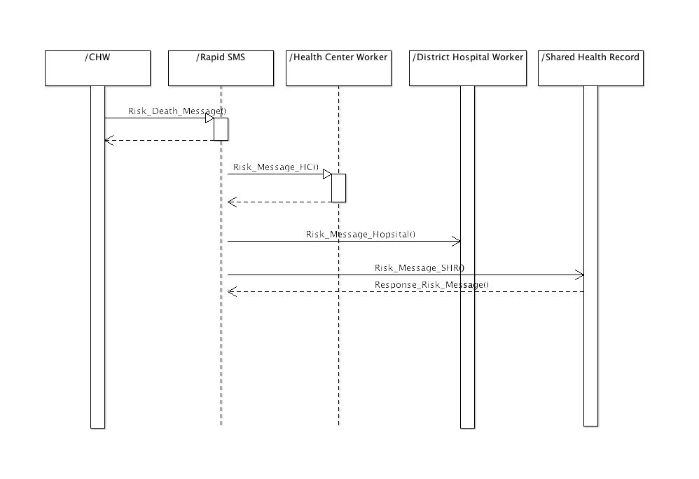

Alternative Workflows

< First alternative workflow >
CHW – phones directly to health center and or hospital and or ambulance

Navigation (Screens Workflow)
To be defined

Special Requirements
No special requirements were identified up to now.

Pre-conditions

CHW finds pregnant woman
A CHW finds a pregnant woman that presents one or more of the conditions above described

Post-conditions

Maternal Risks / Deaths pregnancy message sent
The Report Maternal Risks / Deaths pregnancy message was sent by the CHW to Rapid SMS.

Rapid SMS sends risk message to HCWs
Rapid SMS sends message to the health center worker of the catchment area of the village where the pregnant woman comes from and to the district hospital health care worker informing that there is a pregnant woman at risk in this region.

Rapid SMS sends risk message to SHR
Rapid SMS also sends this message to the shared health record and SHR acknowledges the message was received.

Extension Points

SHR sends risk message to point of care application
UCXX – Shared Health Record sends Risk message to the POC application (OpenMrs)

