RHEA Implementation Iteration 1
The Initial Iteration of the Rwanda Health Enterprise Architecture Project will implement the foundational components (patient registry, provider registry, facility registry, terminology services and a shared health record) that have been defined within the Rwanda Health Enterprise Architecture. In this initial phase, the operation of these components within the national healthcare system, will be implemented in a limited number of primary health facilities within a single district in the country.
This model addresses the requirements for interoperability - data exchange - between the components and the individual primary health facility. It is assumed that the data interchange will be managed by an "interoperability layer" to be implemented along with the foundational components.

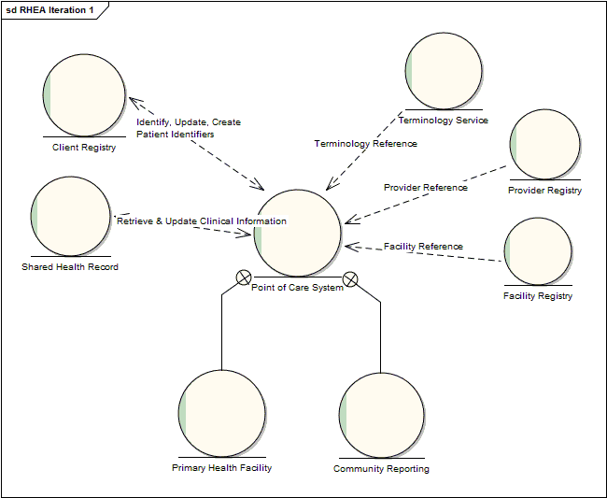
Figure 1 : RHEA Iteration 1

Community Reporting
Object:

Point of Care System
Object:
A system that either provides patient care or other services directly to patients, or that captures information that is needed to manage the health of the population.

Provider Registry
Object:
The Provider Repository manages key information for health care providers (practitioners) who provide medical and other services in the healthcare system. This provides a single source for information on clinicians in order to support consistent identification of the persons involved in providing care to patients. Over time, this will allow consistent quality reporting, management of education programs, health care resource planning and other important functions.

Shared Health Record
Object:
The shared health record contains key demographic and clinical data for patients who have received care in participating facilities.

Client Registry
Object:
A registry of patients that makes it possible to manage a lifetime record of care across patient stays. the registry should make relevant patient data available to systems which are providing treatment to patients.
Data will be loaded into the registry from existing national systems, but only for the district chosen as the RHEA pilot location. Once the initial load has been accomplished, patients will be added and updated based on activity at those primary health facilities where the RHEA systems are implemented

Facility Registry
Object:
A site/server/capability that is capable of managing the identity and related information for health care provider facilities - and associated resources - as well as health care practitioners - and their specialties and associated capabilities.
Such a system can be used as a reference file to validate the identity of a provider or practitioner and to associate them with a location. An additional set of capabilities would be to support resource referrals, and resource scheduling.

Primary Health Facility
Object:
Primary care is the foundation of Rwanda’s healthcare system. For most Rwandans, it is the first and most frequent point of contact with the healthcare system. It may include, for example, consultation at health centers, care by a midwife or nurse practitioner, or a visit to a private clinic.
Primary care is the component where most new health problems are identified and addressed, and where patients and providers work together to prevent and/or manage most diseases. In Rwanda, the most common place to receive primary care is at primary health centers.
Within the RHEA Iteration 1 project, functionality is limited to the care provided to pregnant women (antenatal care, delivery and postpartum follow up) as well as the entry of the baby into the system (including registration into the patient registry).

Terminology Service
Object:
A site/server/capability that is capable of managing the different code systems and value sets (vocabulary) that are needed to support processing by the system and its components.
It should be a repository for the different vocabularies (code sets) that are used, and also support the need of systems for updated vocabularies when the list of valid codes changes.

Identify, Update, Create Patient Identifiers
This section addresses the functionality needed to support consistent patient identification through reference to a central Client Registry. The use cases and activity models address the processes needed to enable patient care systems to access the client registry to support patient identification, as well as those needed to manage the addition of new clients, and the correction of relevant data for existing clients.
The reader should note that the use cases and activities do not provide any account of the Shared Health Record. However, in practice, that record will be updated and accessed in parallel with the Client Registry.

Use Cases and Activities
The use cases define the scope of the needed functionality, and identifies the parties involved. The functions to be implemented are described generally here, and are further elaborated - when it seemed appropriate - using activity diagrams.
The use cases are partitioned into two categories: patient management - primarily driven by the provider, and identifier management - primarily driven by the client registry.

Client Registry
Actor:

Primary Health Facility
Actor:

Patient Managment
The patient management use cases focus on linking patients at the health center to the national ID, and on maintaining the integrity of that connection. They are initiated by the Primary Care Facility.

Patient Registration
This package includes those identification tasks directly associated with patient care - with managing patient identity in the context of encounters.
Note: when I put these together, the distinction between recognized and unrecognized patients seemed important, and it does have implications for the amount of disruption that RHEA I1 will have for the work flow in the primary health facility system. At this point, however, the distinction looks less meaningful, and the two may end up being merged.

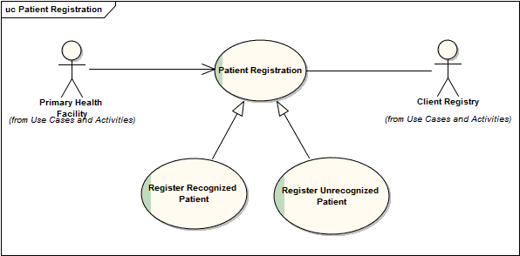
Figure 2 : Patient Registration

Patient Registration
UseCase:
When a patient arrives at the primary health facility to start an encounter, it is necessary to establish the patient's identity and to record significant demographic and personal information. If the patient is known to the institution, then existing information is verified to determine whether or not it has changed.
At the same time, it is important to assure the patient's identity at the national level, to either verify that a record for that patient exists in the client registry, or to create one. So, while the registration of a patient is initiated by the Primary Health Facility, the Client Registry participates in order to validate the National Identifier assigned to the patient.
The workflow that takes place at the Primary Health Facility is decisively influenced by whether or not the patient is already known to the facility. For this reason, two more specialized use cases are recognized - Register Recognized Patient, Register Unrecognized Patient. The workflow for each of these is more precisely defined within the associated activity model.
Note, recognition of the patient can be established by the patient providing evidence of either the National Identifier or of a local identifier provided by the Primary Health Facility at an earlier visit. Recognition can also be established during the registration process if the patient provides demographic information - name, address, phone number, physical description - that corresponds to an existing patient record managed by the Primary Health Facility.

Register Recognized Patient
UseCase:
A recognized patient is one whom the person registering that patient can find within the healthcare provider's database. After an initial phase following the rollout of the client registry, one can expect that the National ID will be one of the items of data recorded for the patient. Therefore, the process of patient identification only requires checking demographic details within the provider's record against those recorded nationally, and confirming both sets with the patient.
During the initial phase, when a returning patient does not have an assigned National ID, it is necessary to access the Client Registry and - passing the patient's demographic details - request an ID for the patient. If the patient is recognized by the Client Registry, their assigned ID will be provided, if the patient is not recognized, this will be noted and a new ID will be assigned. (Note, this last statement assumes the Client Registry is capable of interactively providing new identifiers.)

Register Unrecognized Patient
UseCase:
A unrecognized patient is one whom the person registering that patient cannot find within the healthcare provider's database. Either the person is truly someone who has never been to the facility before, or the demographic information they present does not match that of any current patient (and they have no card or other medium carrying the provider assigned patient id to offer). In this case, a new record within the provider system is created for the person, and their demographic details elicited. If the person offers a National ID, the Client Registry is queried to acquire the demographic details that it can provide. This information is checked with the patient and recorded. If a National ID for the patient is retrieved, it will be stored within the patient's record.

Register Recognized Patient
The work flow for patients who are returning to a patient care facility - who are recognized patients - is significantly different than the one for patients who are being seen for the first time. The reason for this is that - once an identification regime using the Client Registry has been in place for a time - the national ID for these patients can be expected to be on file. Checking these patients will be a matter of verifying their national ID, and addressing potential updates in demographic information.

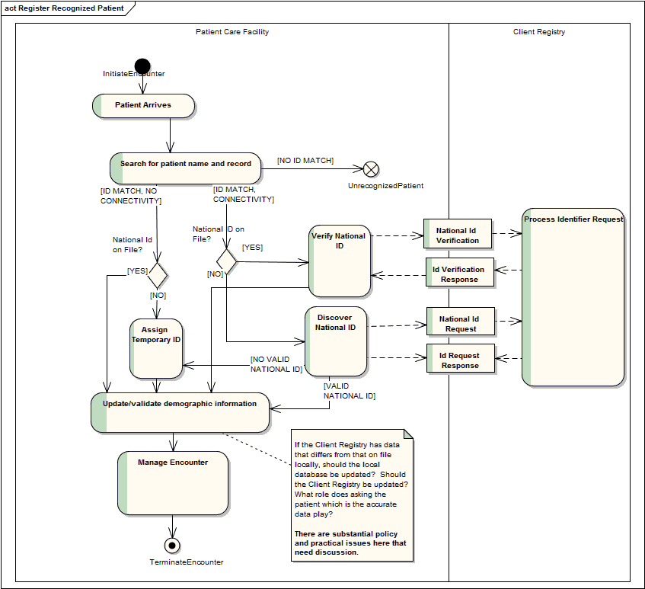
Figure 3 : Register Recognized Patient

Assign Temporary ID
Activity:
If a National ID cannot be assigned to a patient - if connectivity to the Client Registry is not available, or if the Client Registry is unable to assign a National ID - if the submitted information does not pass validation rules, then a temporary ID must be assigned. The identifier characteristics must guarantee national uniqueness, and the assigned identifier must never be reused.
At a later time, the Client Registry will be contacted to exchange the temporary ID for a permanent one.

Discover National ID
Activity:
If the National ID for a patient is unknown, then the Client Registry needs to be queried to determine if such an ID exists. In order to address the case in which the patient is not registered within the Client Registry, the ID request needs to include sufficient demographic information to allow the creation of a new National ID.
If the ID response indicates that a National ID cannot be assigned to the patient, then a temporary ID will be created.
If the ID response indicates several possible IDs for the patient, the one whose demographic details matches should be chosen. If none of the matches seem reasonable, than a temporary ID should be created.

Manage Encounter
Activity:
This process represents the various activities to be carried out during a primary care visit. Refer to the documents "Primary Care Final v2.xls" and "Primary Care Clinic Processes - Final v1.pdf" for more details.

Patient Arrives
Activity:
The patient arrives at the facility to be seen. They may be signed in by the facility and given a place to wait pending formal registration.

Process Identifier Request
Activity:
The Client Registry will process requests to verify a National ID, and requests to add a National ID (if such a function is determined to be feasible and advisable). Once the request is processed, an appropriate response will be sent.

Request National ID
Activity:
The activity is activated if the facility has connectivity to the Client Registry.
A National ID must be requested for the infant. The request to go to the Client Registry needs to include the infant's name and all related demographic data.
When the response is received, if it accepts the request, then the newly assigned National ID is recorded into the database as an item of patient information. The process of providing an ID card will be initiated.
If the request is rejected, and the reason for the rejection can be addressed immediately, an updated National ID request is issued. If it cannot be addressed, then a temporary ID must be assigned.

Search for patient name and record
Activity:
The patient starts the process of formal registration with the primary health facility. The first step in the process is to determine whether a record for this patient exists within the local data store. This is a key point of departure since the work flow for managing a patient who is recognized is rather different from one that is not.
It is important to note the two scenarios for not recognizing a patient: a) the patient has never appeared at this health facility before, b) while having been at the health facility they both do not bring their identification card, and present demographic data that does not match a current record.

Update/validate demographic information
Activity:
The collection of demographic data is a key step within the patient registration process. If the patient already has a record with the facility, the existing details need to be verified.

Verify National ID
Activity:
The Client Registry must be checked to verify the national ID on file for the patient. This will also be an occasion to see whether the Client Registry is recording different demographic information than is found within the patient record. If there are any difference, it will be important to review these with the patient to determine whether the patient's information has changed.

Id Request Response
Object:
This response can take several forms. It can accept the request, and return a national ID for the person. It can reject the request, if one or more IDs are found that match the person. It can reject the request, indicating that insufficient demographic details have been provided to create a national ID.

Id Verification Response
Object:
The transaction will indicate whether the identifier supplied was a valid National ID. If the ID is invalid, the reason for its rejection will be provided.

National Id Request
Object:
The request for a National ID to be issued must include the defined identifying demographic information for the person to whom the ID is to be issued.

National Id Verification
Object:
The transaction contains those elements needed to perform verification of the National ID presented by the patient.

InitiateEncounter
ActivityInitial:

TerminateEncounter
ActivityFinal:

UnrecognizedPatient
FlowFinal:

Register Unrecognized Patient

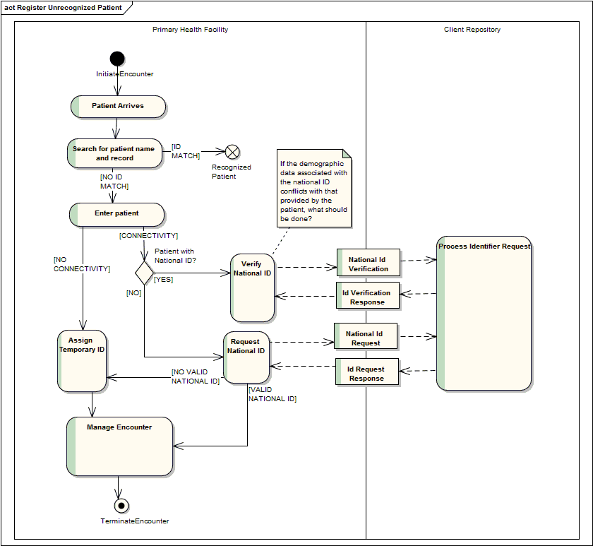
Figure 4 : Register Unrecognized Patient

Enter patient
Activity:
Having determined that the patient is not identified within the system, relevant demographic and other data is collected. This may include their national ID, if the patient has brought the relevant ID card.

Recognized Patient
FlowFinal:

Vital Statistics
This folder includes identifier management when births and deaths are recorded.

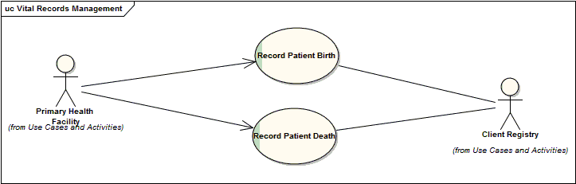
Figure 5 : Vital Records Management

Record Patient Birth
UseCase:
When a baby is born, a corresponding record needs to be created at the Client Registry, and a National ID issued. The creation of a new record is initiated by the Primary Health Facility at the point of birth - if it takes place within the facility - or a day or two after when the infant is brought to the facility for an initial visit. (In Rwanda, the community health worker will direct a parent to take the baby for a visit once the health worker learns that a new baby has been born.)

Record Patient Death
UseCase:
When a patient dies within a Primary Health Facility, it is necessary to notify the Client Registry so their National ID can be deactivated.

Record Patient Birth

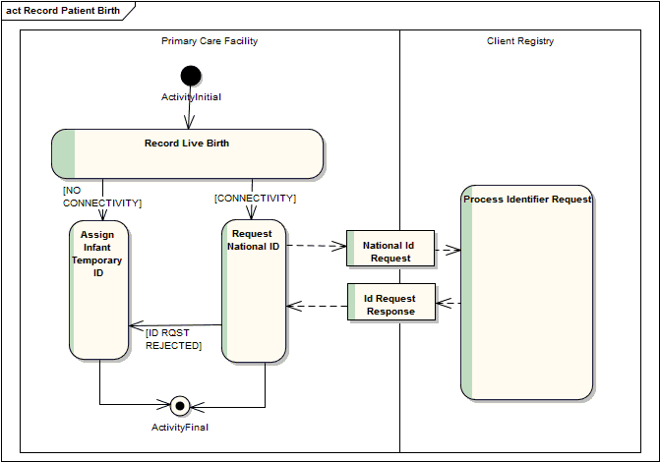
Figure 6 : Record Patient Birth

Assign Infant Temporary ID
Activity:
The activity is activated if the facility does not have connectivity to the Client Registry, or if a National ID request is rejected.
A temporary ID is issued to the infant, and the value assigned is recorded within the patient record. The parents or guardians of the infant are given a card recording the temporary ID.

Record Live Birth
Activity:
When a baby is born, or a newborn is brought to the facility for the first time, they need to be registered as a patient. In addition, characteristic information related to the birth is recorded.

ActivityFinal
ActivityFinal:

ActivityInitial
ActivityInitial:

Record Patient Death
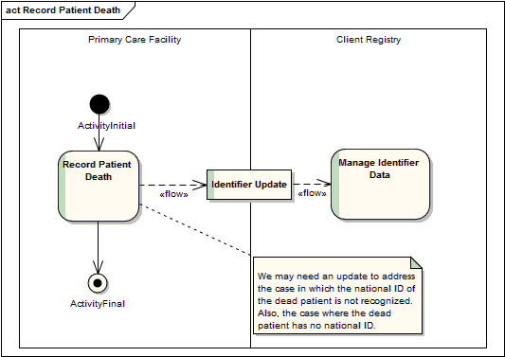
Figure 7 : Record Patient Death

Manage Identifier Data
Activity:
The patient's record needs to be updated to record the fact that the patient has died and the identifier is no longer active.

Record Patient Death
Activity:
When a patient dies during an encounter with a primary health facility, it is necessary to record the time of death, the cause of death, and the additional data elements required by law and/or by clinical practice.

Identifier Update
Object:
The request to update a patient record must contain the information that is to be changed - the patient status, and sufficient information to identify the patient.

ActivityFinal
ActivityFinal:

ActivityInitial
ActivityInitial:

Identifier Managment
The identifier management use cases focus on the creation of the set of identifiers, and its management over time. For the most part, these use cases are initiated by the Client Registry.

Registry Management

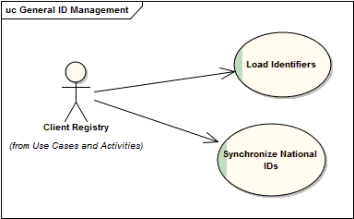
Figure 8 : General ID Management

Load Identifiers
UseCase:
The first step in implementing national patient identifiers is to load the Client Registry with existing identifiers and associated personal information. In Rwanda, the source of the data load is the existing National ID database - for persons 16 and over, and the Database managed by the Ministry of Health.
This use case is not further expanded because its execution lies outside of the RHEA project.

Synchronize National IDs
UseCase:
The Client Registry exists alongside a national ID database maintained outside of the Ministry of Health. As both databases grow, and are updated, it will be important to ensure their contents do not diverge.
This use case is not further expanded because its execution must be shared with other parties, and any solution has to be developed along with the other stakeholders.

Manage Duplicates

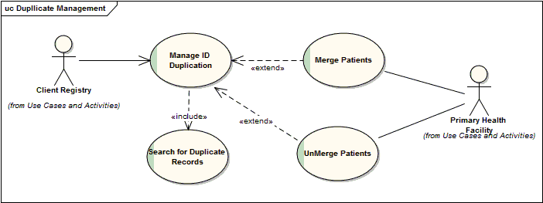
Figure 9 : Duplicate Management

Manage ID Duplication
UseCase:
As patients are added to the Client Registry, it can be expected that the system will end up with multiple records providing information for a single person. This is most likely to happen when a person, returning to a facility without carrying their ID card, is recorded as a new patient and has a new National ID issued. Or, if the visit is to a new facility, the search for their National ID is not successful and a new National ID is requested.
However the source of duplication, managing the problem starts with detecting duplicate records, and continues by merging relevant data into a single record while marking the Identifiers rendered obsolete as such.

Merge Patients
UseCase:
When it has been determined that a group of records contain information relating to the same person, the records need to be merged. The surviving record will contain the demographic information considered to be most reliable. If repeating information such as records of provider encounters is included within the Client Registry, that information will be accumulated from all the included records and re-associated with the surviving record. (The other records will be inactivated - but not deleted from the database.) It will be necessary to ensure that Primary Health Facilities which have information on the patient associated with the inactivated records are notified of the change of National Id.

Search for Duplicate Records
UseCase:
Periodically, the Client Registry will query its database to detect duplicate records. This is done by running programs to detect records in which the demographic data items, e.g., name, address, are so similar as to suggest common identity. (In such searches, names are typically transformed based on phonetics to capture name variations based on spelling mistakes.). Such a program will provide lists of potential duplications along with a probability to indicate the likelihood the records refer to the same person. Such a list must be reviewed by the appropriate person who will determine which sets of records need to be merged into a single one.

UnMerge Patients
UseCase:
It is possible that two records that have been merged will have been done so by mistake, and that the mistake is corrected. Therefore, one aspect of managing duplicates is inclusion of the capability to un-merge two records that have been merged. As with merging of records, it is necessary to make the Primary Health Centers aware of the change.

Duplicate Management

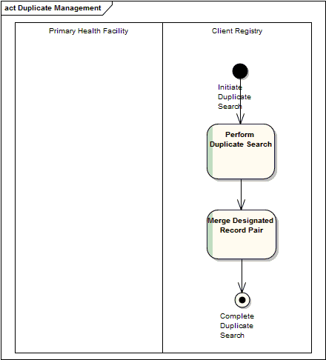
Figure 10 : Duplicate Management

Merge Designated Record Pair
Activity:
The merge process requires that a person with administrative privileges will evaluate the supposed matches to determine, on a case by case basis whether two records are to be merged.
For each pair of records that need to be merged, the record which is to survive will have been identified. The other record has its status set to inactive, and a note made of the record it has been merged with. It is assumed that, during the merge process, the items of demographic data which are to survive the merge have been designated so that the chosen surviving record can be updated if that is necessary.

Perform Duplicate Search
Activity:
The objective is to review the list of enrolled clients to discover duplicate records, that is to say situations in which there are multiple records - each with its own national Id which are associated with a single person. A statistical algorithm is run to identify, based on common data within the individual records, the possible matches. The algorithm will also estimate the probability that a pair of records belong to the same person.

Complete Duplicate Search
ActivityFinal:

Initiate Duplicate Search
ActivityInitial:

UnMerge Patient

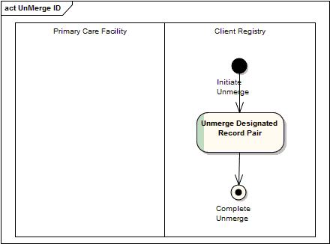
Figure 11 : UnMerge ID

Unmerge Designated Record Pair
Activity:
In some cases, a responsible person will determine that two records which have been merged really represent separate persons. In this case, the merge process must be reversed so that the records can be returned to their original state. (For this reason, the data existing at the beginning of a merge has to be preserved.)

Complete Unmerge
ActivityFinal:

Initiate Unmerge
ActivityInitial:

Resolve Temporary ID

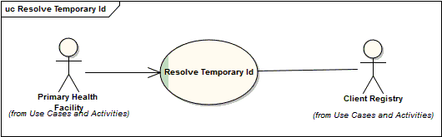
Figure 12 : Resolve Temporary Id

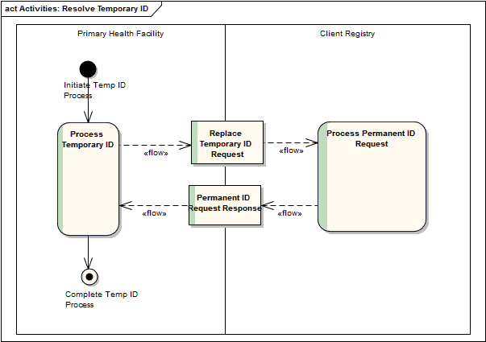
Figure 13 : Resolve Temporary ID

Process Permanent ID Request
Activity:
Once a request to assign a National ID is received, the system will search the registry to determine whether it already contains a record for this person. If there is a potential match, it must be evaluated by a person with the appropriate privileges to determine if there is an actual match.
If not matching client is discovered, a National ID will be issued, and a positive response issued. If a matching client is discovered, the request is rejected.

Process Temporary ID
Activity:
Periodically, the set of temporary identifiers must be processed to determine if they can be replaced with permanent identifiers. The current design assumes this is a process to be initiated by the primary health facility in which a request for a replacement ID is issued. If a positive response is received, the temporary ID for the patient within the primary health facility system will be replaced by the permanent ID. If the request is rejected, the primary health system will need to update the patients information (presumably on a subsequent visit) so that needed information can be acquired.

Permanent ID Request Response
Object:
The response should include - if the request was successful - the assigned National ID for the client. If the request was rejected, the response should include the reason for the rejection.

Replace Temporary ID Request
Object:
The request to replace a temporary ID needs to include sufficient demographic information on the patient to allow a search of the database to discover whether that patient has already be issued an ID, and sufficient data to justify creation of a new record if no matching person is in the system.

Complete Temp ID Process
ActivityFinal:

Initiate Temp ID Process
ActivityInitial:

Resolve Temporary Id
UseCase:
Since connectivity between the Primary Health Center and Client Registry cannot be guaranteed, there will be times when the health center must receive new patients that it does not have a national Id for. In these cases, a temporary ID is constructed. The rules for constructing this ID must guarantee uniqueness and must also prevent collision with permanent ID values.
Periodically, the Primary Health Center will need to communicate its list of temporary IDs to the Client Registry, so that they may be replaced by permanent IDs.

Retrieve & Update Clinical Information

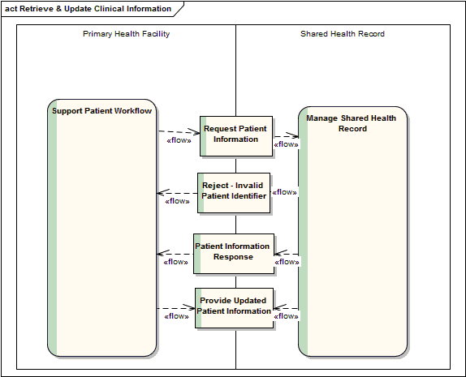
Figure 14 : Retrieve & Update Clinical Information

Manage Shared Health Record
Activity:

Support Patient Workflow
Activity:
Facility information is needed to record the location where the patient is receiving care, or to indicate a location the patient will be referred to.

Patient Information Response
Object:

Provide Updated Patient Information
Object:

Reject - Invalid Patient Identifier
Object:

Request Patient Information
Object:

Facility Reference

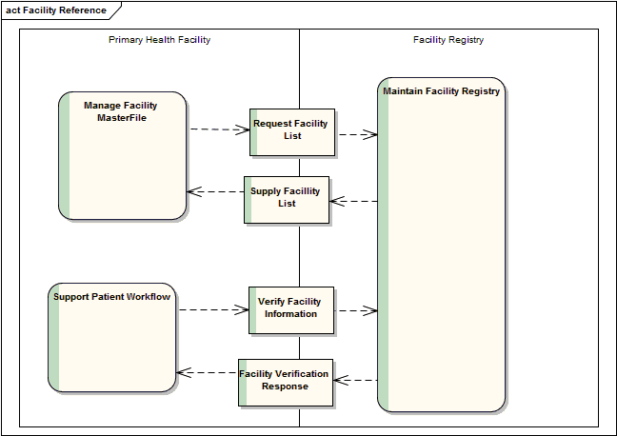
Figure 15 : Facility Reference

Maintain Facility Registry
Activity:
Management of the facility registry is based on existing data that identifies and characterizes healthcare facilities in the country. Over time, this data will be centrally updated.

Manage Facility MasterFile
Activity:
A local list of facilities is maintained in order to support application function if it is not possible to communicate with the central registry. In addition, support of a local data store may be necessary given the architecture of the patient care application in question.

Support Patient Workflow
Activity:
Facility information is needed to record the location where the patient is receiving care, or to indicate a location the patient will be referred to.

Facility Verification Response
Object:

Request Facility List
Object:

Supply Facillity List
Object:

Verify Facility Information
Object:

Terminology Reference

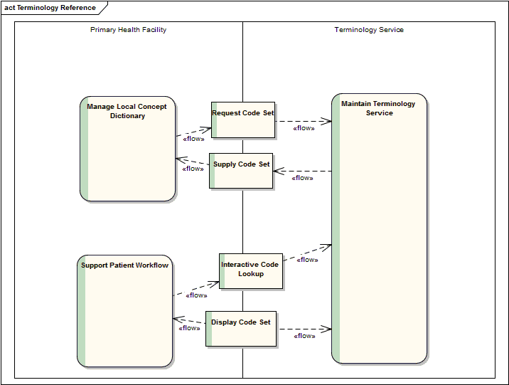
Figure 16 : Terminology Reference

Maintain Terminology Service
Activity:
Management of the terminology service includes the initial loading of the chosen reference terminologies, and the maintenance of those terminologies as new coded concepts are added, modified, or retired.

Manage Local Concept Dictionary
Activity:
A local set of the codes to be used from the relevant terminology is maintained in order to support operations when the national terminology server is not available. In addition, support of a local data store may be necessary given the architecture of the patient care application in question.

Support Patient Workflow
Activity:
Facility information is needed to record the location where the patient is receiving care, or to indicate a location the patient will be referred to.

Display Code Set
Object:

Interactive Code Lookup
Object:

Request Code Set
Object:

Supply Code Set
Object:

Provider Reference
Once a central Provider Registry has been developed, it is necessary to ensure that the sites delivering patient care can use the information. The package describes the data interchanges needed to support use of the registry.
Two modes of communicating are shown, one in which the local care site (the Primary Health Facility) manages a local data store of provider information, and one in which needed provider references are captured directly from the central registry.

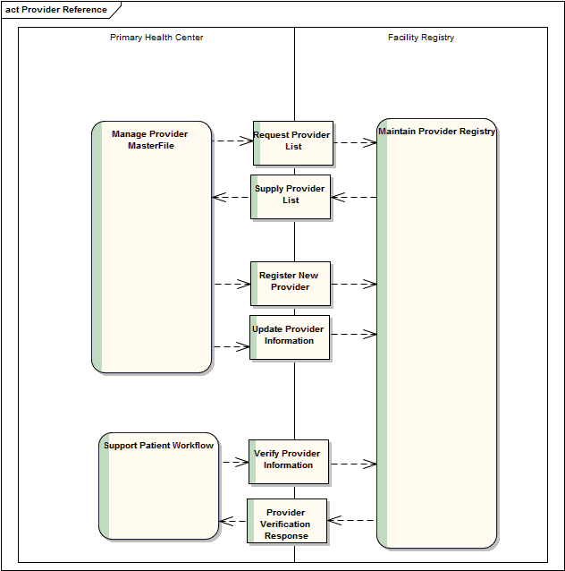
Figure 17 : Provider Reference

Maintain Provider Registry
Activity:
Management of the provider registry is based on an initial load of provider information using existing sources of data. Over time, as the list of providers changes, and as new provider information is added, the registry system will support the functions needed to track a changing population. It is NOT expected that all updates will occur through requests from local health facilities.

Manage Provider MasterFile
Activity:
A local list of providers is maintained in order to support application function if it is not possible to communicate with the provider registry. In addition, support of a local data store may be necessary given the architecture of the patient care application in question.

Support Patient Workflow
Activity:
Provider information is needed when a provider is assigned to provide care to a patient, or when a patient is being referred to a particular provider.

Provider Verification Response
Object:

Register New Provider
Object:

Request Provider List
Object:

Supply Provider List
Object:

Update Provider Information
Object:

Verify Provider Information
Object:

